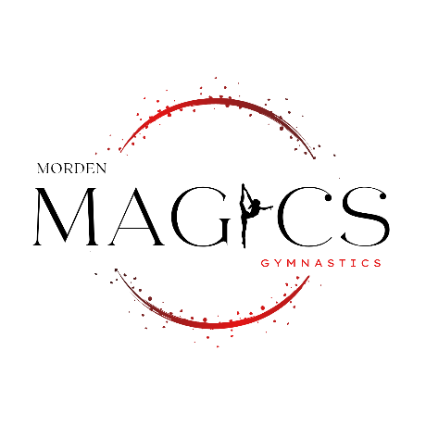**Morden MAGICS Gymnastics Club**

**Spring MAGIC Classic**

**Regional Stream Invitational Competition**

**March 7-9, 2025**

# Access Event Centre

# 111D Gilmore Street

Morden, Manitoba

***PLEASE NOTE: FACILITY DOES NOT OPEN BEFORE 8AM***

All Female Levels 1 – 6 and Xcel Gold athletes are invited.

*Please note there is no spring floor

# Registration fee: Level 1-6 & Xcel Gold $115 per gymnast

**CLUBS:** Please submit one cheque payable to:

Morden Magics Gymnastics Club.

Box 102

Morden, MB R6M 1A2

**OR**

One e-transfer to: [treasurer.mordenmagics@gmail.com](mailto:treasurer.mordenmagics@gmail.com) Please specify in the memo who and what this is for.

Spreadsheet must be completed and forwarded to magics.coach@gmail.com

Registration will not be considered complete until payment and signed waiver forms are received.

Only registered coaches will be allowed on the floor and in the coaches room.

**REFUNDS:**

**REFUND REQUESTS WILL BE ACCEPTED UPON THE RECEIPT OF A MEDICAL REPORT SIGNED BY A PHYSICIAN. THERE WILL BE A $40.00 ADMINISTRATION FEE FOR ANY REFUND GRANTED**

# Registration Deadline: February 7th, 2025

**Competition times to follow.**

**Contact: Jen Martens**

**Email: magics.coach@gmail.com**